
Children with Down’s syndrome - How our Paediatric Audiology Department will support your child.
Many children with Down’s syndrome have some degree of hearing loss. This is usually due to glue ear but some children may have a sensorineural (permanent) hearing loss.
We can provide regular assessments of your child’s hearing. From birth up to the age of 5 you will be offered a yearly review of your child’s hearing. After the age of 5 your son/daughter will be offered a hearing assessment every two years until they reach adulthood.
At the audiology appointment we will discuss with you any concerns re listening skills, speech and language development, hearing fluctuations, and general health matters including ear infections and/ or upper respiratory tract infections. We will carry out an assessment of hearing and tympanometry which indicates how the middle ear is working.
What happens if a hearing loss is detected?
This will be dependent on the type of hearing loss diagnosed. The most common hearing loss in young children is a conductive loss as a result of glue ear.
What is glue ear?
It is common in many young children, especially over the winter months
It is fluid that builds up behind the eardrum in a space called the middle ear which is usually filled with air.
It can be present in one or both ears
It usually improves by itself but sometimes can persist and may cause a hearing loss which can fluctuate over time.
Why does it happen?
Coughs, colds or ear infections can cause the Eustachian tube, which connects the middle ear to the back of the throat, to become blocked with mucus causing fluid to build up in the middle ear space. This may affect your child’s hearing.

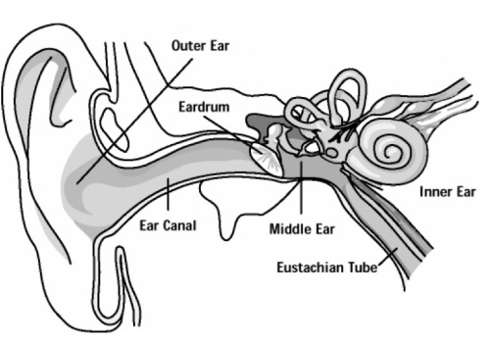

We will discuss with you as a family how this may be impacting on language development and social interaction. Initially we would advise a watching and waiting period of 3 months to see if the glue ear resolves without any treatment. If at the next assessment hearing is still affected the following options could be considered:
Hearing aids: either behind the ear or bone conduction aids.
Referral to ENT for consideration of grommets – may not be appropriate in young children as the ear canal may be too narrow – but as a family you will be able to have a discussion with consultant to see if this is a viable option.
Some children may have a sensori neural loss which is the result of some difficulty in the inner ear. If your child is diagnosed with this hearing loss we would discuss with you as a family how this may be impacting on language development and social interaction.
We would advise referring your child to the ENT department to see if any investigations are necessary re the cause of the hearing loss.
Hearing aids: we would discuss with you whether you wish to consider hearing aids for your child which would be programmed to support their hearing loss.

We are happy for parents/carers to contact us at any time if they have concerns re their child’s hearing and we will try and arrange a review appointment as soon as is possible.

The Paediatric Audiology Team

