
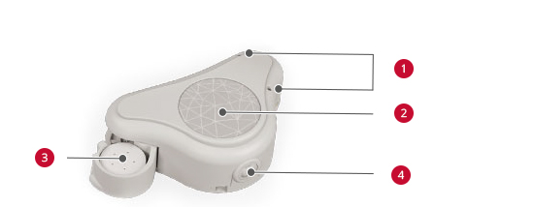
The ADHEAR system

- Microphones
- Programme button
- Battery compartment
- Volume control

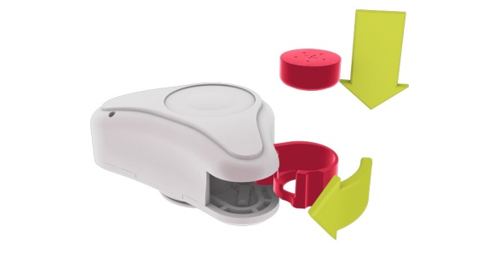
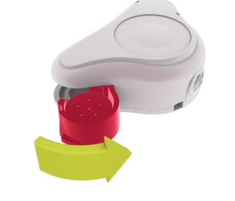
Switching ON/OFF

Close battery compartment to switch ON Open battery compartment to switch OFF

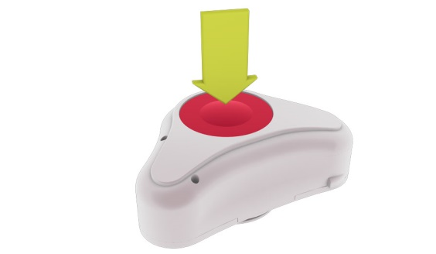
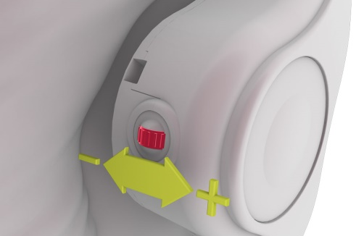
Volume control Programme button
Scroll away from head to increase volume Press button to change programme
Positioning ADHEAR

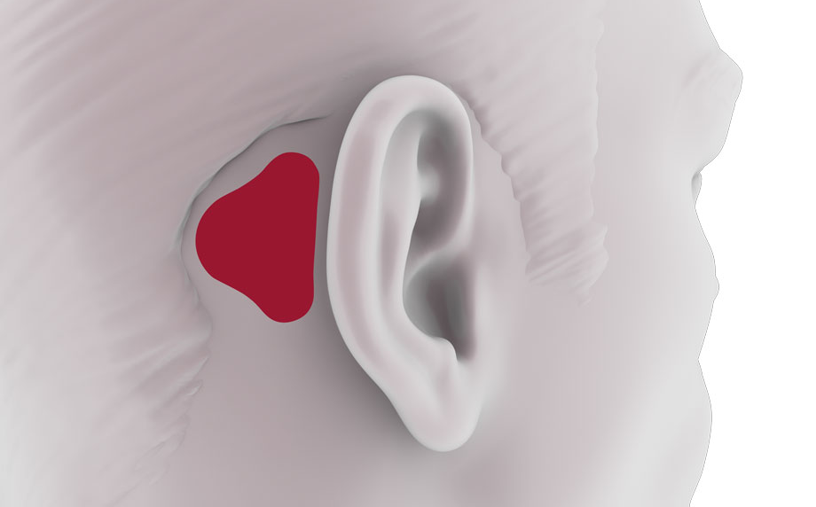

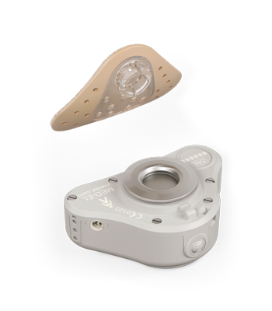
The skin behind the ear must be clean, dry and free from hair.

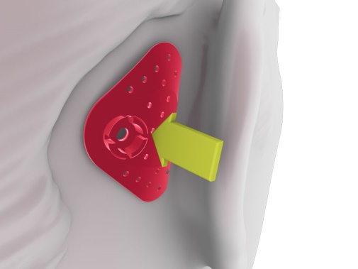
Press down firmly on the entire surface of the adhesive adapter for at least 30 – 60 seconds.
The adhesive pad can be kept on when bathing, showering and other water based activities.
If you would like more Adhesive pads to be ordered please contact Audiology Department.

