

Tips for staff in Key stage 1 & 2 supporting children with hearing difficulties


Face them when you are talking to them – ensure that they can see your face clearly, try not to move around as you are talking.

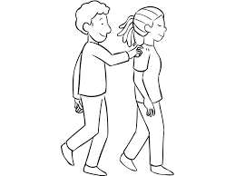
Get their attention before you speak to them so that they know you are talking to them.

Where possible use visual objects to support learning goals and write key vocabulary on the board, this will help children to understand the correct context of the lesson.

= Fruit


Where possible reduce background noise.


Check they have understood what you are talking about, they may need you to repeat or rephrase an instruction.

