Tips for Early Years Settings supporting children with hearing difficulties

Face them when you are talking to them – try to get down to their level so that they can see your face clearly; try not to move around as you are talking.

Get their attention before you speak to them so that they know you are talking to them.
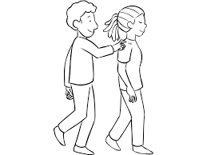

Stand with your face to the light, standing by a window can make it difficult to see your face .

Where possible reduce background noise.

Check they have understood what you are talking about, they may need you to repeat or rephrase an instruction.

