SUSPECTED LOWER GASTRO-INTESTINAL CANCER REFERRAL FORM
Referrals to be sent via e-RS

Referrer Details | Patient Details
Name: | Forename: | Surname: | DOB:
Address: | Address: |  | Gender:
Address: |  |  | Hospital No:
Address: |  |  | NHS No:
Tel No: | PLEASE CHECK TEL Nos ARE CORRECT  Tel No. (1):
Tel No: | Tel No. (2):
Email: | Carer requirements (has dementia or learning difficulties)? |  | Does the patient have the capacity to consent?  Yes No
Decision to Refer Date: | Translator Required: Yes No  Language: |  | Mobility:
Level of Concern

I think it is likely that this patient has cancer and would like the patient to be investigated further even if the FIT is negative.

Clinical details
Please detail your conclusions and what needs to be excluded or attach a referral letter.

Colorectal Cancer
When considering referring any patient over the age of 18 years for investigation of possible colorectal cancer (EXCEPT those with rectal bleeding, palpable mass, obstructive symptoms or iron deficiency anaemia) please give the patient a FIT kit to complete and review the result before referring.

Please also ensure that all bloods (FBC, U&E, eGFR, Ferritin) have been taken within the last 8 weeks and please review results before referring as this helps with triaging patients and ensures patient suitability for particular investigations.
- If the FIT test is positive (≥ 10 μg/g) please refer via this form along with up to date blood test results.
- If the FIT test is negative (<10 μg/g) the patient should be followed up in Primary Care with relevant safety-netting advice recorded in the notes.
For patients with unexplained symptoms, (where alternative pathology seems unlikely), please get
“Advice and Guidance” from Secondary Care clinicians.

Any age with: (no FIT test required)
Rectal mass Abdominal mass
Aged 40 and over with:
Unexplained weight loss AND Abdominal pain AND Positive FIT test.
Aged under 50 with: (no FIT test required)
Unexplained rectal bleeding: (Please tick whichever apply)
fresh/ bright red on paper altered/mixed with stool melaena

AND any of the following:
Unexplained abdominal pain

Unexplained weight loss

Iron deficiency anaemia

Change in bowel habit : (Please tick whichever apply)

loose constipated non-specific changes

Aged 50 and over with: (no FIT test required)

Unexplained rectal bleeding : (Please tick whichever apply)

fresh/ bright red on paper altered/mixed with stool melaena

Aged 60 and over with:

Iron Deficiency Anaemia (no FIT test required)
OR

Positive FIT test AND Change in bowel habit: (Please tick whichever apply)

loose constipated non-specific changes

Anal cancer (no FIT test required)
Unexplained anal mass OR
Unexplained anal ulceration

Information helpful for deciding appropriate appointment type:

Is the patient fit for oral bowel preparation?

Yes No

Is the patient willing to undergo colonoscopy or CT Colonography (as appropriate)

Yes No

Bloods required for each patient:

Ferritin: |  | Results within last 8 weeks please
Hb: |  | Results within last 8 weeks please
Creatinine: |  | Results within last 8 weeks please
eGFR: |  | Results within last 8 weeks please
FIT numerical result (if appropriate) | μg/g | Results within last 8 weeks please

Anaemia Iron Deficiency
Male: Hb <110g/l , Ferritin 24 - 336 μg/l
Female: Hb <100g/l Ferritin 11 – 30 μg/l

PR Exam performed: Yes No

PLEASE TICK AS APPROPRIATE
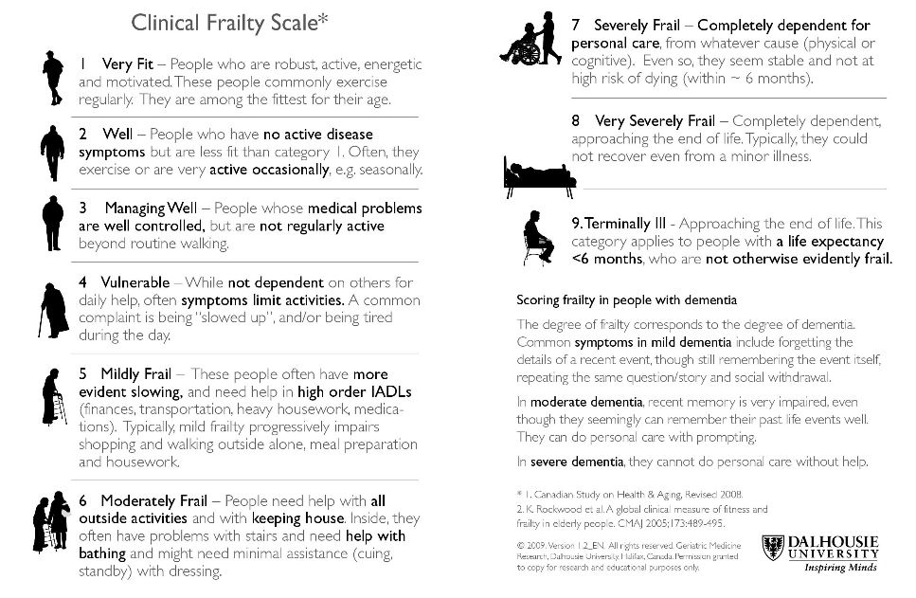

Smoking status
Yes No Ex-smoker
BMI if available
Date:………………. BMI ……………..

Please confirm that the patient has been made aware that this is a suspected cancer referral: Yes No

Please confirm that the patient has received the two week wait referral leaflet: Yes No

Please provide an explanation if the above information has not been given:

PLEASE STATE Date(s) that patient is unable to attend within the next two weeks:

If patient is not available for the next 2 weeks, and aware of nature of referral, consider seeing patient again to reassess symptoms and refer when able and willing to accept an appointment.

Please attach the additional clinical issues list from your practice system
Details to include:
Current medication, significant issues, allergies, relevant family history, alcohol status and morbidities

Trust Specific Details:

For hospital to complete UBRN: Received date:

