I wrote your name

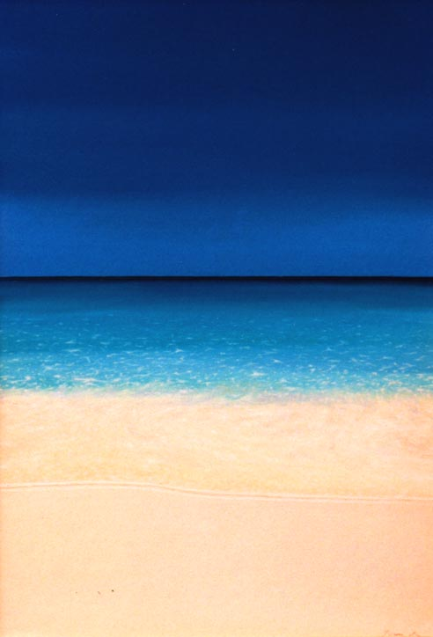

I Wrote Your Name
I wrote your name in the sand,
but the waves washed it away.
I wrote your name in the sky,
but the wind blew it away.
So I wrote your name in my heart,
and that’s where it will stay, always.

Unknown author

