Passover Information
sunset 27th March 2021 – sunset 4th April 2021
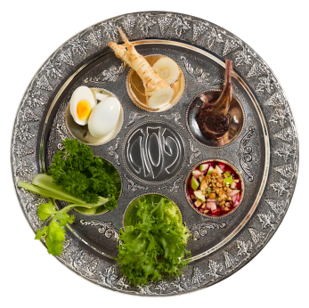
History and Biblical Tradition
- Passover is a Jewish festival lasting eight days, marking the exodus from Egypt of the Children of Israel, their liberation from centuries of harsh slavery and the birth of the Hebrew nation.
- Passover (or PESACH, as it is usually referred to,) is one of the three Foot (or Pilgrimage) festivals in the Jewish calendar, where the Jewish people were commanded to bring produce to the Temple in Jerusalem. The other two Foot festivals are Shavuot and Succoth. These three festivals also have agricultural significance. Passover is also known as the festival of Spring, the festival of Matzoth (unleavened bread), the season of our freedom, and the festival of the paschal lamb (Exodus 12, 3-20).
- The name Passover relates to Exodus 12:27, in which the Angel of Death “passed over” the homes of the Children of Israel.
- In the Jewish calendar, Passover always begins on the 15th day of the Jewish month of Nisan. Dates will vary from year to year in the secular calendar.
- All Jewish festivals start at sunset.
- During the first two evenings a “Seder” will be held. Seder means “Order”, and at this time we retell our story of liberation as if we ourselves were slaves in Egypt. The prayer book we use is known as the Haggadah (The Narrative.) This narrative is particularly important to our children, and, in time, their own children. We may also reflect upon modern-day slavery.
- At the Seder table, there will be a decorative plate. This plate will include foods of significance. A roasted egg symbolises life. Salt water represents the tears of the Children of Israel. Bitter herbs remind us of the bitterness of slavery. Green vegetables such as parsley and lettuce remind us of the greenness of Spring. The paschal lamb is represented on the seder plate by a shank bone. A mixture of apple, cinnamon, wine and crushed or ground nuts is intended to resemble the mortar the slaves used in their hard labours.
- Four cups of wine or grape juice are drunk. One extra cup is reserved for the prophet Elijah.
- At the second Seder, we begin counting the Omer; there are 49 days which separate Passover and the next Foot/Pilgrim festival of Shavuot. Traditionally, we express the hope that next year we will be in Jerusalem.

- Prior to Passover, a search is make for leaven (“Chametz”) in order to remove it from the home. This custom commemorates the hurried departure of the Children of Israel from Egyptian slavery; there was no time available when baking with a leavening agent, such as yeast for their bread to rise, before their rushed exodus to freedom.
Implications for patients and staff
- There are a number of dietary rules, in addition to the Jewish dietary laws, which make Passover so significant.
- Unleavened bread is known as Matzoth. During Passover, observant Jewish patients and staff will eat Matzoth instead of any usual breads. Occasionally, some patients might be more prone to constipation because of this dietary observance, particularly if impaired mobility is a clinical issue.
- Traditionally, crockery and cutlery are changed to a set reserved for Passover. In a hospital setting, observant patients may possibly wish to use disposable crockery and cutlery.
- Specific foods should be certified as being “Kosher for Passover” during the festival.
- There can be differences between what is permitted and what is forbidden between Ashkenazi and Sephardi Judaism, and so it is better to ask than to err.
- Families may wish to bring in foods from home at this time, and every effort should be made to respect this.
- To wish somebody a “Happy Passover” say: “chag Pesach sameach.”
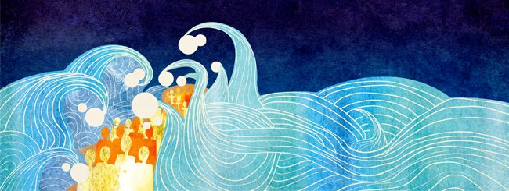
This information has kindly been provided by members of the
Jewish Small Communities Network. If you would like more information or support, please contact the chaplaincy: chaplaincy.community@somersetft.nhs.uk

