Health Passport
Adult Services
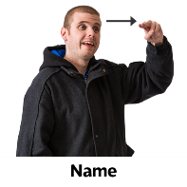  Name:  ( I like to be called) | Hospital Number:
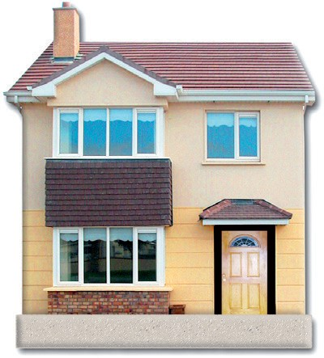  Address: |   Date Of Birth:
  Telephone Number: | 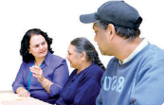  Language I use to communicate:
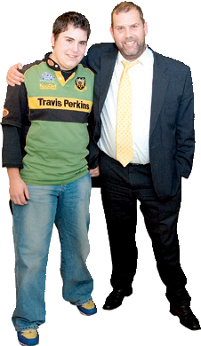  Next of Kin:  Address:  Telephone number: |   Religion
Any Relevant Care Plans / Forms. (Please bring these with you)

Eating and Drinking

End of Life

Other

People involved in your care: ( named consultants, neurologists, health, social care, GP)

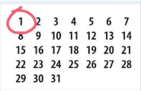


Completed By: Date: Signed:

Mental Capacity Act 2005
If I am assessed as lacking capacity and not able to make decisions about my treatment or discharge planning when I am in hospital, the following people must be contacted in any decisions made in my best interest.
Name | Relationship | Contact details | Lasting Power Of Attorney: Please circle
 |  |  | Finance | Welfare
 |  |  | Finance | Welfare

Essential information
Very important information you must know about me
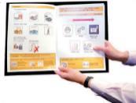
Diagnosis and medical conditions (Including Autism)

Allergies:
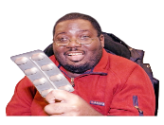
Medication: (Please always bring a list of the medication you take)
How do you take your medication and what time do you take it?

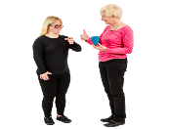
How I communicate: ( verbal, non-verbal, braille, written, sign language)
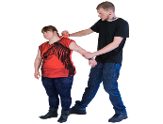
Behaviours that may cause risks to self, others or the environment: (biting, head-butting, harming myself)

Triggers that may lead to behaviours that challenge and ways to support me: (changes in routine)

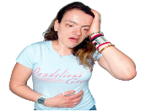
Pain / distress indicators and how to make medical test easier: (How do you show you’re in pain. How can staff support you during medical tests)

Important routine and keeping safe: (Do you require supervision during a hospital stay? What routines do you have at home)
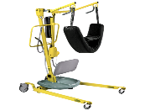
Equipment, setting and sizes
(positioning, hoist, bed rails, trachy/NG size, ventilation settings)


Previous admissions and procedures (i.e. implants such as a pacemaker or VNS, Do you have any metal plates, have you had any operations before?)

If you are having a general anaesthetic are there any other procedures that can be done at the same time?
(I;e, toe nails being cut whilst having a general anaesthetic for dental surgery)

Important Information
Important information about my general living
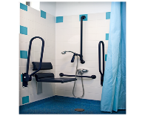
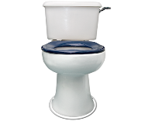
Support needs: (Washing and dressing, toilet needs, personal hygiene)
Eating and drinking (support required, temperature, texture, equipment, likes, dislikes. Please read my eating and drinking care plan if I have one.)

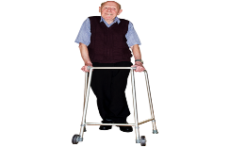
How I move around: (Wheelchair, frame, hoist, walk)

Breathing (asthma, sleep apnea)

Expressing emotions (how do you express if you are happy, sad, worried, scared?)
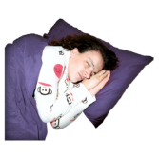
Sleeping (do you have a routine, sensory needs)
Have you got any problems with your:
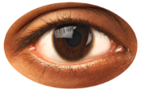  Sight: | 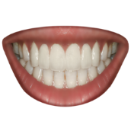  Teeth:
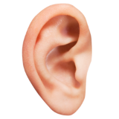  Hearing: | 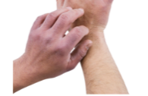  Skin:

Preferable information
What will make my hospital stay better
Things you like and things that make you happy
Things you dislike and things that may upset you
Things that will make your hospital stay better

Traffic Light System

RED
Essential information

This is very important information you must know about me!
Within the red section above, should include the extremely important information health care staff should need to know about you.

In addition to this, if the red section does not cover what you see as really important information please use the additional space below to record.

Within the amber section above, should include the important information with regards to general living tasks that health care staff should need to know about you.

In addition to this, if the amber section does not cover what you see as information that staff need to be aware of please use the additional space below to record.
AMBER
Important information

This is important information about my general daily living.

Within the green section above, should include the
Information health care staff should need to know about you that will help them to know you a little bit more.

In addition to this, if the green section does not cover what you see as really important information please use the additional space below to record.
GREEN
Preferable information

This is information about my likes, dislikes and how best to comfort me.

Additional Information

This Health Passport has been adapted by Somerset Partnership NHS foundation Trust and is based on the original Hospital passport by Gloucestershire NHS Trust.

The aim of this Health Passport is to provide all health care staff with necessary information that may be required during health appointments or hospital admissions. It will help health care professionals to meet your needs to ensure you are getting the care you require.

Please take this document with you to health appointments or hospital admissions.
Please ensure that this document is kept up-to-date and reviewed regularly. This document is your responsibility to keep up to date and not the responsibility of the Learning Disability Service.

This hospital passport can be found on the Sompar public website and by searching Learning Disabilities or alternatively by calling 01823 668790 and somebody will be able to help you.

Image © Copyright 2006 photo symbols Ltd. All rights reserved.

GREEN
Preferable information

This is information about my likes, dislikes and how best to comfort me.
AMBER
Important information

This is important information about my general daily living.
RED
Essential information

This is very important information you must know about me!

