Low Back Pain (MSk Physiotherapy) https://www.youtube.com/watch?v=23NQ52SWPjw&feature=youtu.be

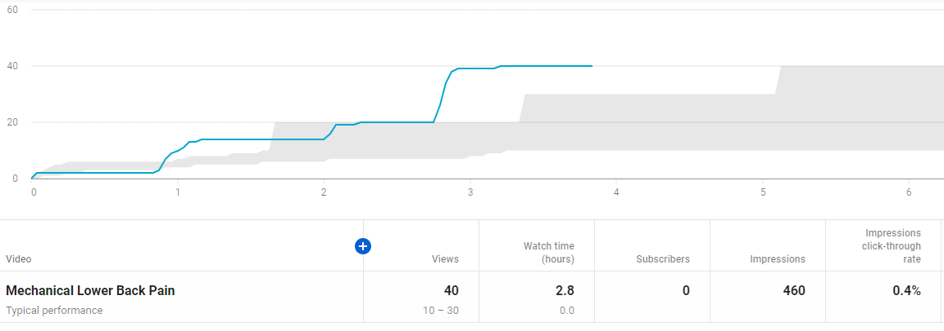

Average View duration: 4.13s
Average percentage viewed: 35.9%

GTPS https://www.youtube.com/watch?v=z9w5axHITms

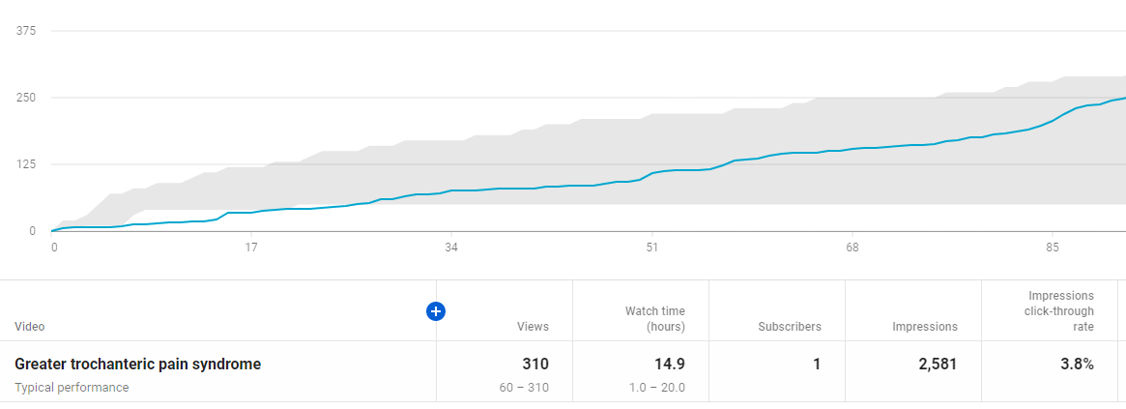

Average view duration: 2:52s
Average percentage viewed: 42%

Patellofemoral Pain https://www.youtube.com/watch?v=OAYXnXAn9k8

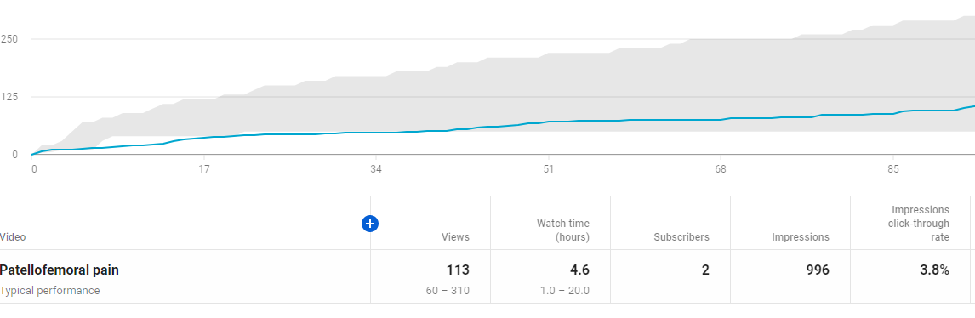

Average view duration: 2.24s
Average percentage viewed: 28.3s

OA knee https://www.youtube.com/watch?v=pmnLLsuz04E

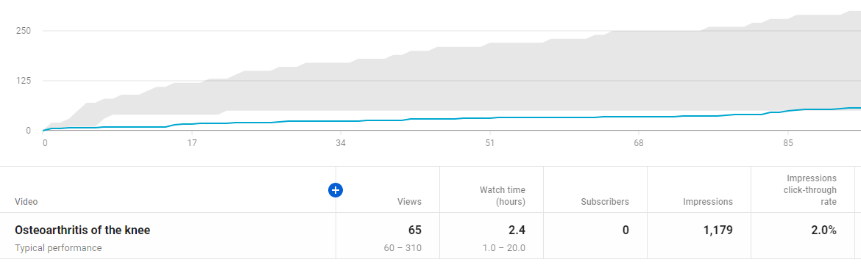

Average view duration: 2.10
Average percentage viewed: 20.3%

Carpal Tunnel Syndrome https://www.youtube.com/watch?v=TFMCt4VLSBA

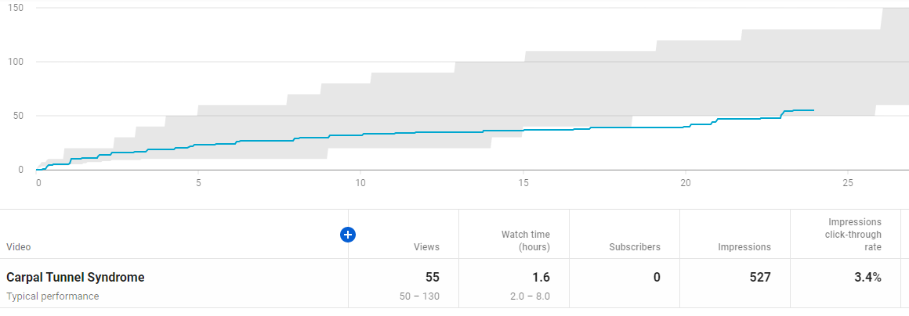

Average view duration: 1.42s
Average percentage viewed: 28.5%

Subacromial Pain https://www.youtube.com/watch?v=cOq-OraMiyg

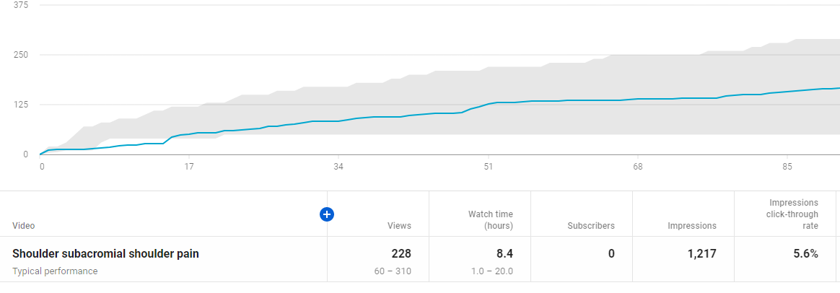

Average view duration: 2.12s
Average percentage viewed: 29.8%

Tennis elbow https://www.youtube.com/watch?v=1yOMytWyF54

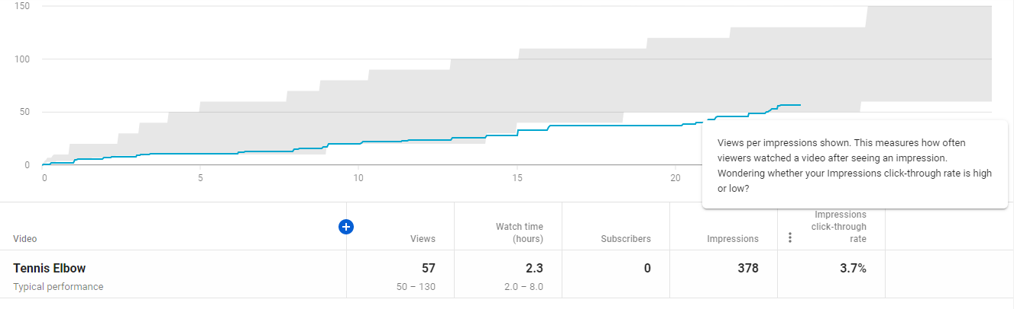

Average view duration: 2.20s
Average percentage viewed: 34.3%

